**Aim: Create a Cloning of a VM and Test it by loading the Previous Version/Cloned VM**

**Step 1:** Create an virtual machine.

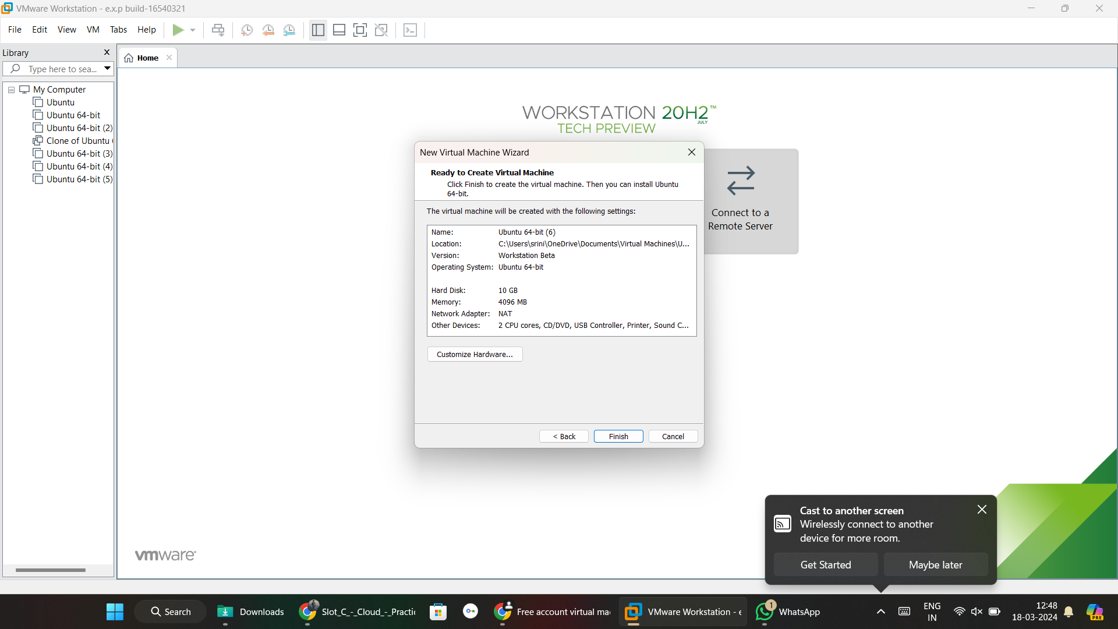

**Step 2:** Select VM and click on manage, we can see clone option.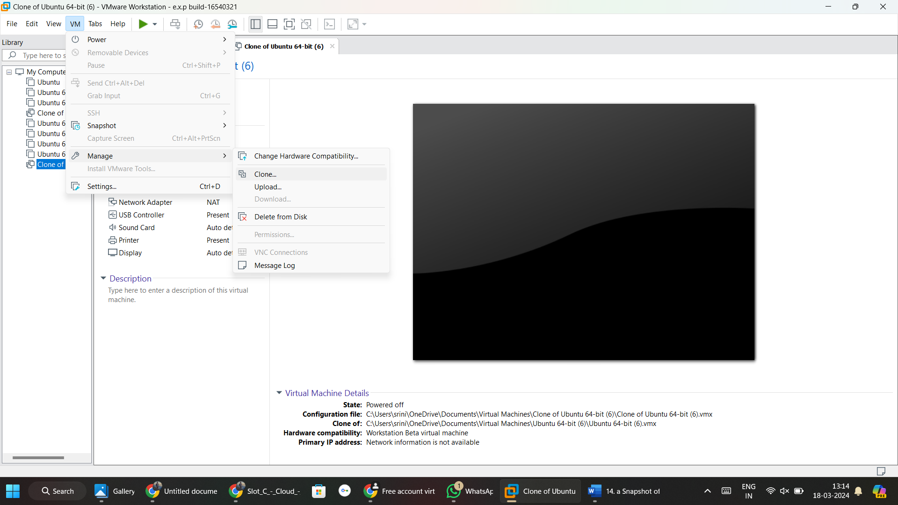

**Step 3: VM was created.**

